Lesson 1 Place value

Oral and mental starter 10 minutes
Ask pupils to write the number 5.7, multiply it by 10 and record their answer.
Objectives
Understand and use decimal notation and place value; multiply and divide integers and decimals by 10, 100, 1000, and explain the effect (Y7)
Read and write positive integer powers of 10 (Y8)
Vocabulary
place value, zero place holder, tenths, hundredths, thousandths, equivalent, equivalence, power, index
Resources
OHT of M1.1
Ask a pupil to read their answer aloud and to explain how they arrived at it.
Q What has happened to the digits? (Note that the decimal point does not move; the digits shift one place to the left.)
Repeat with numbers involving one and two places of decimals, asking pupils to multiply and divide by 100 and 1000.
Q What do 10² and 10³ mean?
Q How do you write 10 000 as a power of 10? How do you write 10 as a power of 10? What about 1?
Ensure that pupils recognise that increasing powers of 10 underpin decimal notation.
Extend to division to cover 10⁰ and negative powers of 10.
Choose numbers from the place value chart (OHT M1.1) and ask pupils to multiply and divide them by integer powers of 10 (using powers of 10).

Main teaching 40 minutes
Introduce the spider diagram (OHT M1.2). Ask pupils to explain the results and to consider other solutions, using the digits 4, 0 and 1 only . Invite pupils to show their responses and to talk through their reasoning. Make sure that 4 = 0.04 ÷ 0.01 is considered.
Objectives
Extend knowledge of integer powers of 10 (Y9)
Multiply and divide integers and decimals by 0.1, 0.01 (Y8)
Vocabulary
place value, zero place holder, tenths, hundredths, thousandths, equivalent, equivalence, power, index
Resources
OHT of M1.2
Handouts of M1.1
OHT of M1.3 (for plenary)
By the end of the lesson
pupils should understand that:
• when a number is multiplied (divided) by 10/100/1000, the digits move one/two/three places to the left (right)
• multiplying by 0.1 has the same effect as dividing by 10
• multiplying by 0.01 and dividing by 100 are equivalent
• multiplying by 10^{–3} and dividing by 10³ are equivalent
Framework supplement of examples, page 39
Levels 5 and 6
Discuss what happens when a number is multiplied/divided by a number less than 1.
Q Does division always make a number smaller?
Does multiplication always make a number larger?
Repeat with 5.7 in the centre of the spider diagram and record pupils’ responses. Establish that there are several different ways of recording the answers. For example:
0.057 × 100 = 5.7 0.057 ÷ 0.01 = 5.7
0.057 × 10 × 10 = 5.7 0.057 ÷ 0.1 ÷ 0.1 = 5.7
0.057 × 10² = 5.7 0.057 ÷ 10^{–2} = 5.7
Ask pupils to work in groups to develop their own spider diagram showing equivalent calculations for other numbers (e.g. 3.2, 67.3, 0.43).
Remind them that their work should be recorded clearly.
Use place value charts (handout M1.1) to support pupils as appropriate.
Differentiate by using different starting numbers for different ability groups and encourage pupils to record their responses in ways in which they are confident.
Move pupils on to develop their understanding of place value and notation through the following stages:
• multiplication/division by 10, 100 and 1000
• multiplication/division by positive integer powers of 10
• multiplication/division by 0.1 and 0.01
• multiplication/division by negative integer powers of 10

Plenary 10 minutes
Use the place value target board (OHT M1.3).
Q If I divide a number by 0.1 and then again by 0.1 the answer is 0.03. What number did I start with? How do you know?
Q Why do 3.3 × 10 × 10 and 3.3 ÷ 0.01 give the same answer?
Ask similar questions to check pupils’ understanding.
Place value chart M1.1
0.001 | 0.002 | 0.003 | 0.004 | 0.005 | 0.006 | 0.007 | 0.008 | 0.009
0.01 | 0.02 | 0.03 | 0.04 | 0.05 | 0.06 | 0.07 | 0.08 | 0.09
0.1 | 0.2 | 0.3 | 0.4 | 0.5 | 0.6 | 0.7 | 0.8 | 0.9
1 | 2 | 3 | 4 | 5 | 6 | 7 | 8 | 9
10 | 20 | 30 | 40 | 50 | 60 | 70 | 80 | 90
100 | 200 | 300 | 400 | 500 | 600 | 700 | 800 | 900
1000 | 2000 | 3000 | 4000 | 5000 | 6000 | 7000 | 8000 | 9000

Place value spider diagram M1.2

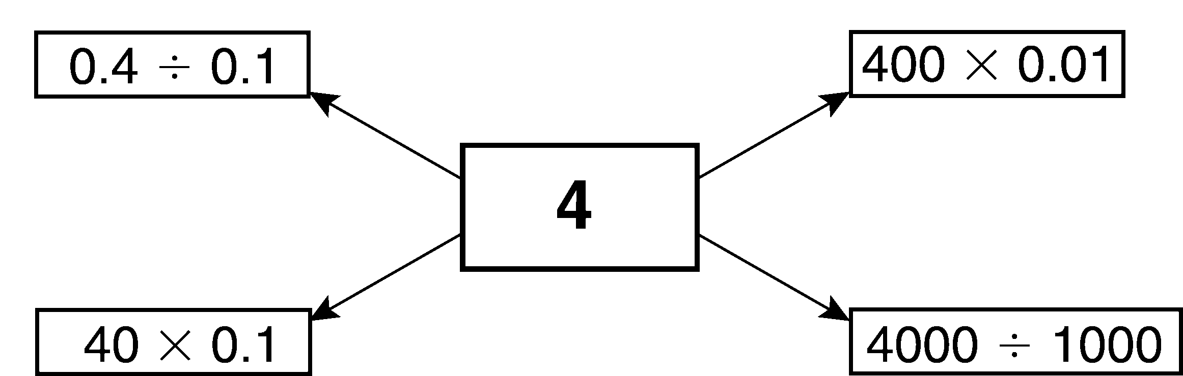
Place value target board M1.3
0.4 | 17.6 | 3
0.33 | 30 | 156
4000 | 1.56 | 1.76
3.3 | 0.0176 | 0.0003

